MD.120 Installation Instructions
Mobile Supply Chain Platform
Author: Subramanian
Document Ref:
Version: 1.2

Title, Subject, Last Updated Date, Reference Number, and Version are marked by a Word Bookmark so that they can be easily reproduced in the header and footer of documents. When you change any of these values, be careful not to accidentally delete the bookmark. You can make bookmarks visible by selecting Tools->Options…View and checking the Bookmarks option in the Show region.

Approvals:
<Approver 1> | Bala Krishnan
<Approver 2>
To add additional approval lines, press [Tab] from the last cell in the table above.
You can delete any elements of this cover page that you do not need for your document. For example, Copy Number is only required if this is a controlled document and you need to track each copy that you distribute.
Copy Number _____

Document Control

Change Record
3
Date | Author | Version | Change Reference
November 8, 2026 | Subramanian |  | No Previous Document

Reviewers

Name | Position

Distribution

Copy No. | Name | Location
 | Library Master | Project Library
 |  | Project Manager
The copy numbers referenced above should be written into the Copy Number space on the cover of each distributed copy. If the document is not controlled, you can delete this table, the Note To Holders, and the Copy Number label from the cover page.

Note To Holders:
If you receive an electronic copy of this document and print it out, please write your name on the equivalent of the cover page, for document control purposes.
If you receive a hard copy of this document, please write your name on the front cover, for document control purposes.
Contents
Document Control ii
Installation Instructions for Subinventory Transfer and Wipcomplete For Anchor 1
Pre-Installation Steps 1
Backup Plans 1
Installation Steps 1
Backout Plans 4
Open and Closed Issues 6
Open Issues 6
Closed Issues 6

To update the table of contents, put the cursor anywhere in the table and press [F9]. To change the number of levels displayed, select the menu option Insert->Index and Tables, make sure the Table of Contents tab is active, and change the Number of Levels to a new value.

Installation Instructions for Mobile Supply Chain Technical Objects
Environment Name: CUSTOM | Machine: <Machine Name>

Pre-Installation Steps

NA

Backup Plans
NA

Scope:
Mobile Supply Chain Platform.
Module: WIPMoveCompletePack with OverCompletion.
APIs: get APIs for LPN.

Installation Steps

List of components

Seq No | File Name | File Type
1 | XXALG_ALL_LPN_LISTS_PKG.pkb | pkb

Step when you migrate from Sqlplus

- Unzip the CodeBundle to any path (for example :F,:E etc.,)
- Loging to sqlplus
- Run the script as @<path which you unzipped>:\anchor\XXALG_SI_WIP_INSTALL.sql for for eg: @D:\anchorlpnmigration\anchor\XXALG_SI_WIP_INSTALL.sql
- Run the below script to check

Your steps should be more specific than the examples shown.

Backout Plans
NA

Screen Short for Reference:
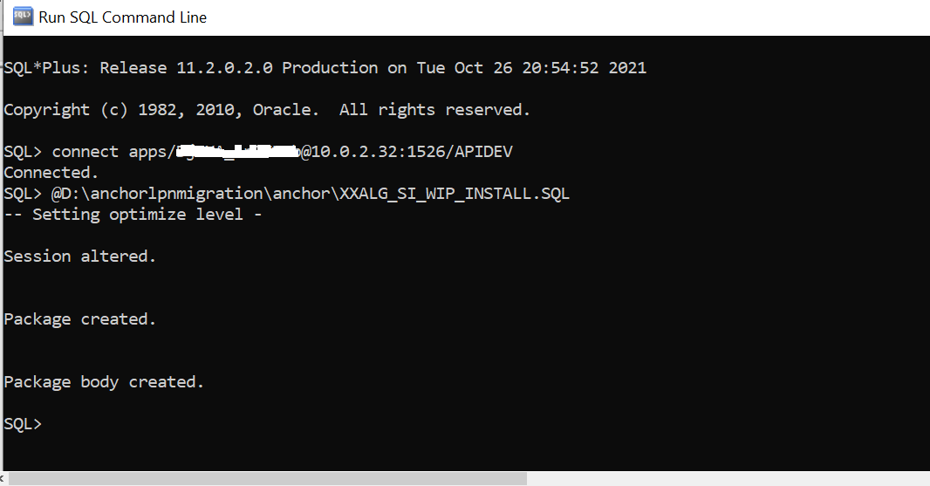

Open and Closed Issues
Add open issues that you identify while writing or reviewing this document to the open issues section. As you resolve issues, move them to the closed issues section and keep the issue ID the same. Include an explanation of the resolution.
When this work product is complete, any open issues should be transferred to the project- or process-level Issue Log (PJM) and managed using a project level Issue Form (PJM). In addition, the open items should remain in the open issues section of this work product, but flagged in the resolution column as being transferred.

Open Issues

ID | Issue | Resolution | Responsibility | Target Date | Impact Date

Closed Issues

ID | Issue | Resolution | Responsibility | Target Date | Impact Date

